# Lab 03: Using LiveBindings

FMX Mobile Application Development

* Add a TPrototypeBindSource
  + Dbl Click -> Add ContactBitmapsL & ContactNames
* Add TListView
  + Find the ItemAppearance.ItemAppearance property
    - Change it from ListItem to ImageListItem
  + Set ItemAppearanceObjects.ItemObjects.Visible to False
* Right Click ListView1 -> Bind Visually…
  + Connect:
    - Sync -> *
    - Item.Text -> ContactName1
    - Item.Bitmap -> ContactBitmatL1

Open the LiveBindings Designer from either the **View** menu or by right-clicking on your form/components.

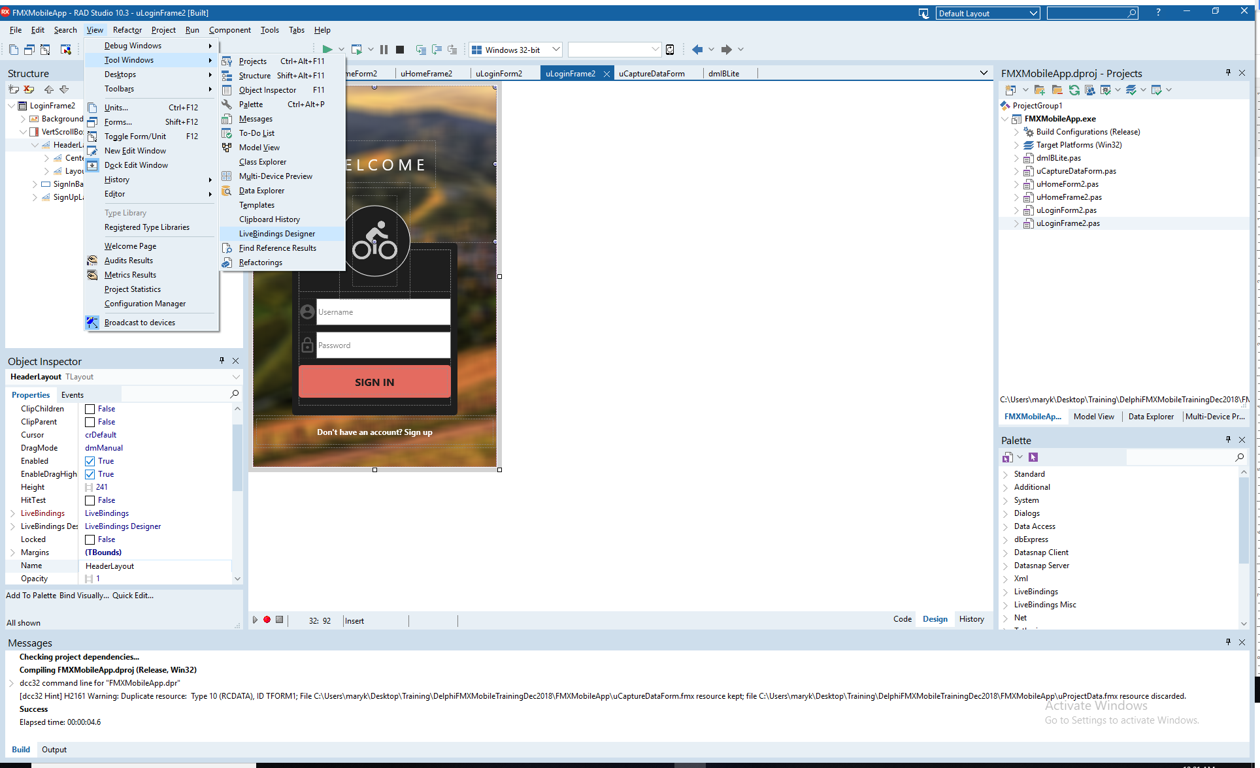

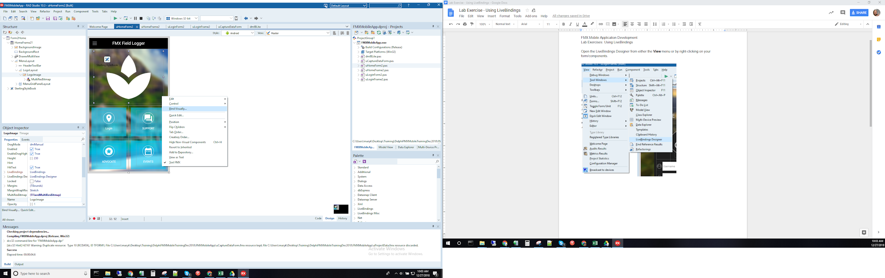

In the LiveBindings Designer, your binding diagram contains just the objects and you are ready to link them.

